Comparing Class Scores in GCSE Modular Science

Dr. J. Welch
The County High School, Leftwich, Cheshire, UK
http://www.drwelch.co.uk

Abstract

Multiple choice tests are used widely in education and elsewhere. The results of these tests contain information both about the students’ knowledge and their ability to guess the answers. The purpose of this paper is to use Bayesian statistical techniques to attempt to ‘remove’ the guess-work from the results in order to obtain information about the students’ underlying knowledge based on our prior knowledge about the structure of the test. The resulting model allows fair comparisons of the levels of knowledge of groups of students in schools and highlights the flaws in the common practice of analysing these scores using simple averages. It also allows more specific comparisons to be made that are not possible using traditional methods.

1. Introduction

A multiple choice test provides the student with a number of options from which they are to select the correct answer e.g.
The Milky Way is a …
- galaxy
- solar system
- Universe
- star

Using such a test to assess understanding can be problematic not least because the person being tested could guess the correct answer without any understanding of the topic. Several workers (see for example [1], [2]) have studied marking systems for such tests (e.g. negative marking) which attempt to address this problem; a good review can be found in [3]. Others have focused on the design of these tests, several workers using Bloom’s ‘taxonomy of cognitive demand’ [4] to devise questions that require more than factual knowledge to answer. A recent example of this can be found in [5]. Others have approached the problem by using computer-based techniques in which the question presented depends upon the success achieved so far. A Bayesian solution to this problem can be found in [6].

In UK GCSE modular science examinations, marks are awarded for correct responses only; there is no ‘negative marking’ or other system of penalising guesswork. The raw scores so obtained are then adjusted to give a universal modified score (UMS). This mapping is in general non-linear and depends on the performance of students across the country. Empirically the mapping is linear in the middle and lower scores, but penalises the highest scoring students as shown in Figure 1.1. These adjusted scores obscure the true performance however, so ‘raw’ scores (where available from the examination board) should always be used in comparing performance and are used throughout this paper. We would like to process the data to find out to what extent the students’ scores were influenced by lucky guessing and how much the scores reflect their knowledge of the subject.

Bayesian methods are statistical techniques that can help in problems such as this, where the data (test scores) are confused by some kind of external influence (guessing). These methods work by incorporating other information we have about the problem (being taught by the same teacher, for example). A Bayesian method incorporates this prior information in a fair way, allowing the data to modify and eventually overwhelm our prior knowledge as the quality and quantity of data increases. Interested readers are directed to [7] for a review of these methods.

As an example we will consider the problem of analysing a single student’s score on a test.

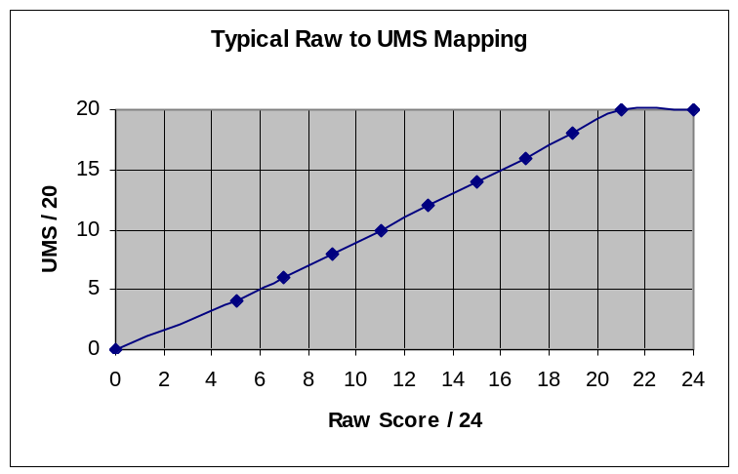

Figure 1.1 – Typical non-linear map from raw to UMS scores

2. Basic Model (I₀)

We will study the results of a student taking a test in which there are L questions with R responses.

Each student is assumed to know the answers to k questions, and to correctly guess g questions. The student will therefore score s = k + g. This is a simplified model because students will often make informed guesses by eliminating some of the ‘confusers’. We are unable to use this information however, because it depends on the individual student and is not identified by the testing method.

We would like to infer the student’s knowledge, k, from their score, s. A Bayesian analysis allows us to set-up the problem to obtain not a single “right” answer for k, but a probability distribution for k indicating our state of knowledge about what k might be. The Bayesian approach is to interpret probabilities such as pr(x) as a ‘state of knowledge’ about x, and to use Bayes’ Theorem to manipulate these quantities. Quantities that are part of the model but are not directly of interest are ‘integrated out’, effectively adding-up the contributions of all possible values. In our case, we will integrate g out of the problem, so that our solution takes into account all possible combinations of guesses.

This Bayesian analysis yields:
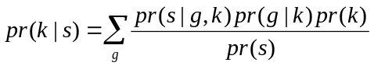
The next step in a Bayesian analysis is to assign prior distributions, that is, decide our state of knowledge about quantities before receiving the data. Without the scores, an analyst who does not know the class would have no preconceptions about k and assume each possible value to be equally likely. We assign a uniform prior distribution in [0,L] on each k. Pr(g|k) is a binomial distribution, selecting g correct from s–k guesses with probability 1/R. Pr(s|gk) is zero unless g=s–k, mathematically pr(s|g,k) = δ(s-(g+k)), selecting one term from the sum. Ignoring the constant factors pr(k) and pr(s) and taking log’s yields:

Figure 2.1 shows the results obtained using this formula for R=4, L=24. Denoting the maximum of the distribution as 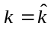 we see that
- 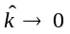for small s consistent with pure guess-work;
- 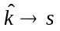for large s where the student is very knowledgeable having little reliance on guess-work; and
- 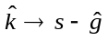 with 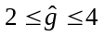 elsewhere, indicating an expected contribution of two to four marks from guess-work for average students.

These results are in line with what we would have expected from ‘common sense’ and we can now develop the analysis to more complex examples.
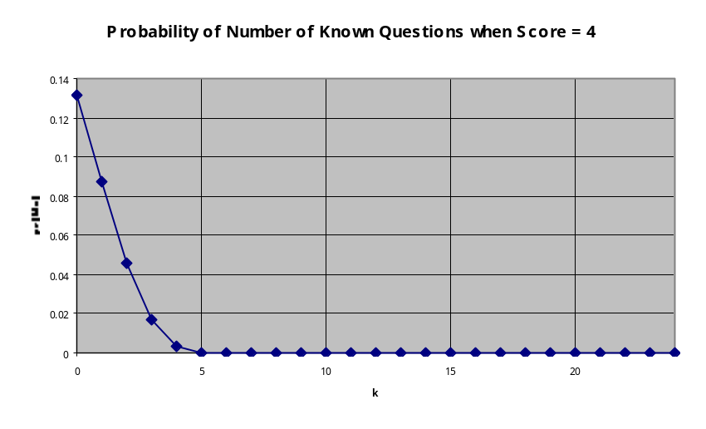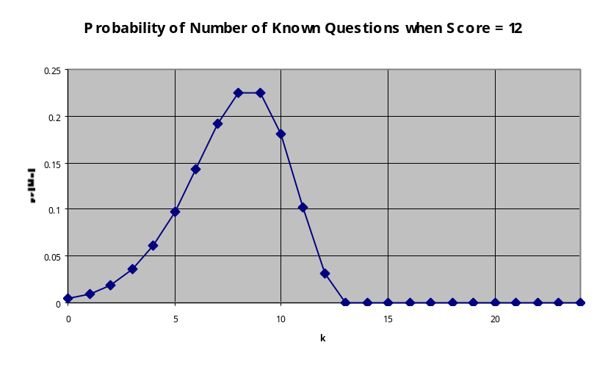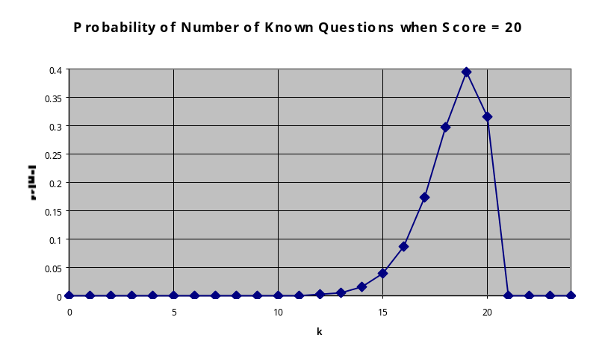

Figure 2.1 – Results of Uncorrelated Model – note scales

3. Whole-class Model (I₁)

We now consider a class of N students. We assume they have been set for ability and have been taught by one teacher. This means that we expect, before they take the test, that there will be some consistency in the scores. We may not believe this very strongly, but when the data arrive our Bayesian method will allow the data to overwhelm these prior beliefs if there is enough evidence for doing so. Mathematically this is done by allowing correlations between the students’ k’s.
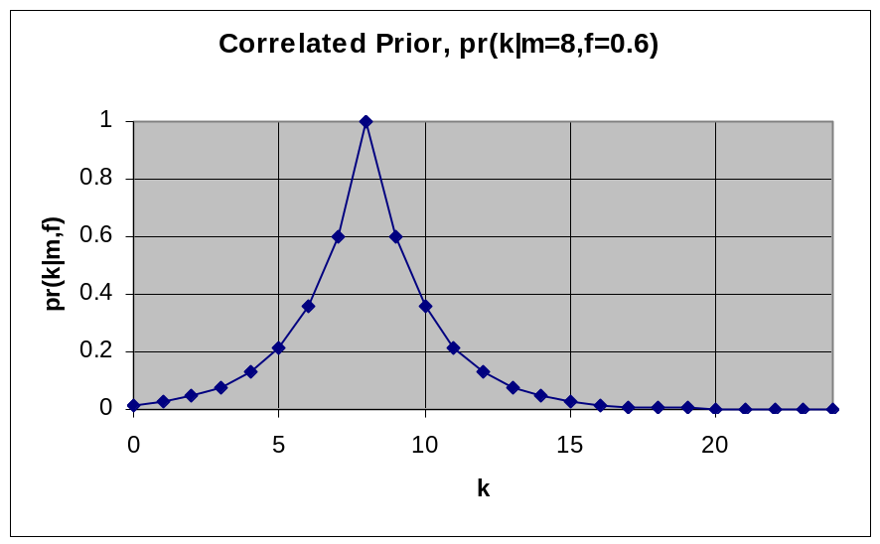

Figure 3.1 – Correlated Prior for k

To model such a correlation, our prior knowledge of the value of k for any student in the class is taken to be centred on a middle value m and having a certain width. We have used an exponential decay model in which pr(k=m+1) / pr(k=m) = constant, f, as shown in Figure 3.1 above. The figure represents our expectation of the spread of students’ knowledge before we see their scores. We expect they will cluster around a central value with a few students knowing more or fewer answers than this.

We are now interested in finding a value of m which gives an indication of the class’ level of knowledge. We use a Bayesian analysis that takes into account the class’s scores, the likely extent of guesswork as described in the previous section, and the expected correlation between their levels of knowledge. This analysis produces not a single answer for m, but a probability distribution for m, allowing us to state our level of belief in any particular value of m given all the information to hand. The analysis is set up as before:

where bold type is used to denote vector quantities such as s = (s₁, s₂, …, s_{N}), the N students’ scores. We ‘integrate out’ the model parameters that are not of direct interest as before, namely f, g, and k, thus taking account of all possible values in a fair way. In the case of g and k, as these are discrete variables, the integration is a sum.

We now need to encode our prior knowledge in the probability distributions in the equation above. Standard Bayesian procedures exist for assigning priors on certain quantities (see [7] for more details). These suggest a uniform prior in [0,L] on m (independent of f) and a prior on f proportional to f⁻¹ in some suitable range 0<f<1. In order to perform the calculations on computer we will discretise f to some suitable resolution in the range. Pr(g|k,m,f) is the binomial distribution discussed before. Pr(s|g,k,m,f) again selects from the sums those g for which s = g + k. Pr(k|m,f) is proportional to 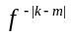 for each k independently, modelling our exponential prior on k centred on m with fall-off rate, f.

Putting all of these ideas together and ignoring the constant pr(s) for the moment yields:
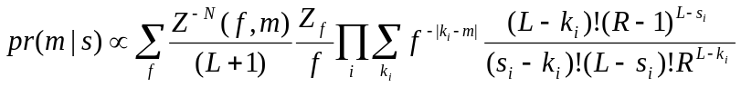
where i is an index running across the students in the group.
Although the quantity of interest is the probability distribution for m, we would like also to obtain pr(s) as this is the probability of obtaining the data based solely on the use of this model. We will call this quantity the ‘evidence’ for the model and we will use it later to compare models. Mathematically we require all other distributions to be normalised so that pr(s) is simply the normalising constant for the final distribution. We have denoted this normalisation for pr(k|m,f) as Z(f,m), and for pr(f) as Z_{f} in the chosen discrete range.

4. Whole-class Results

Artificial (Toy) Data

Three ‘toy’ datasets were generated based on N = 20, L = 24, R = 4. In ToyA, a group expected to achieve ‘A’ grades, each student scored 21. In ToyG, expecting ‘G’ grades, students scored between 6 and 9. In ToyC, expecting ‘C’s, students scored between 9 and 14.

The results are shown as Figure 4.1; each plot shows pr(m|s), the resulting or posterior distribution for m, given the scores. The results show the patterns expected; the model predicts ‘toyA’ knew 20 answers, ‘toyC’ knew 9 answers, and ‘toyG’ knew 3 answers. This is sensible given the basic model where perhaps 2-4 marks are scored from guessing. The correlations have had the effect that the spread of scores in the group is explained by a range of knowledge around m, and by guess-work. Once the guess-work has been accounted for, only a small range of knowledge is required to explain the results, hence the posterior is narrower than the original range in the data.

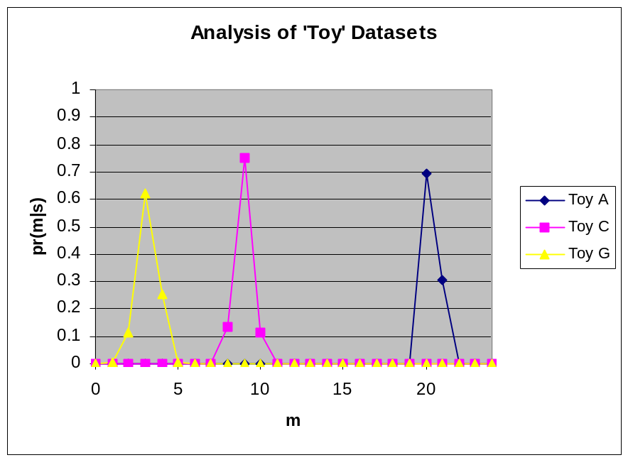

Figure 4.1 – Results for ‘toy’ Data

Real Data

Three real datasets for a GCSE science module test on ‘Inheritance’ were then analysed based on L = 24, R = 4. Data from three classes who took this test were analysed; class 3, N=27; class 6, N=21; and class 8, N=19. The classes are ability sets in numerical order in Year 10, predicted mostly C grades, mostly D’s and mostly F’s respectively. The results are shown as Figure 5.1 below.

In these results we see a similar pattern to the ‘toy’ datasets. In class 8 however, the posterior is flatter and wider. This is due to a larger spread of scores in this class. The posterior shows the model’s lack of ability to distinguish uniquely between spread of ability and spread of luck in guessing. The advantage of the Bayesian approach is that the lack of uniqueness is quantified (has an associated probability level) and can be used in fair comparisons. We shall see later that, with additional information, we can in fact go some way to distinguishing between spreads in ability and in guesswork.

5. Model Comparison

The whole-class model I₁ incorporates our assumption that the scores will be correlated (grouped around m) based on the fact that the class has been set for ability and taught by the same teacher. The Bayesian method allows us to compare this assumption with the assumption I₀ that each student’s performance was individual (that the correlations are not real).

The ‘evidence’ for a model is pr(model|data). Given two models we can compare them using:

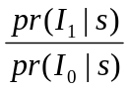 = 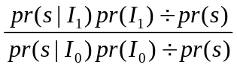

= 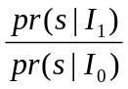

where I₀ and I₁ are the models (between which we assume no preference in advance), and s are our data. The normalising constant for pr(k|s) in the basic model (single student) and pr(m|s) in the whole-class model is associated with pr(s|I_{0/1}) above, the evidence for the model mentioned previously. The ratio measures to what extent the data tell us we should prefer one model over the other. Typically these ratios are large powers of 10 because pr(s) is a product of perhaps 30 independent data, each with probability of perhaps 0.3, resulting in evidence ~0.3³⁰=10⁻¹⁶.

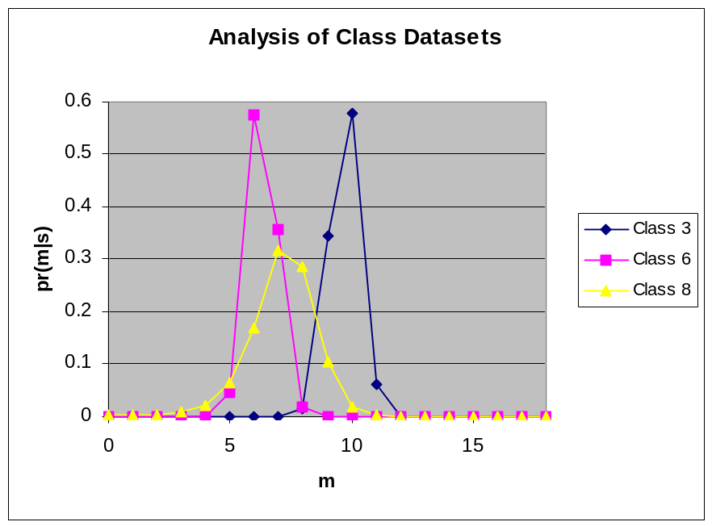

Figure 5.1 – Results for Real Data

Dataset | Evidence for I₀  pr(I₀|s) | Evidence for I₁  pr(I₁|s) | Ratio
Toy A | 3.47E-26 | 1.89E-08 | 5.44E+17
Toy C | 2.88E-26 | 1.60E-17 | 5.58E+08
Toy G | 5.10E-28 | 6.58E-17 | 1.29E+11
Class 3 | 1.59E-36 | 9.43E-29 | 5.95E+07
Class 6 | 5.73E-28 | 7.08E-20 | 1.23E+08
Class 8 | 4.45E-24 | 2.43E-21 | 5.45E+02

Table 5.1: Comparison of Models using Bayesian Evidence

Following this analysis for the toy and class datasets reveals overwhelming evidence in support of the correlations proposed in the whole-class model (see Table 5.1). In other words, the data provide strong evidence for the supposed correlations between students’ knowledge. This is weakest in class 8 where the spread of scores suggests more individuality in the students’ performances.

6. Additional Prior Information

Some examination boards’ papers have still more structure which we can use as prior knowledge in our model. We will consider the case where the questions in the paper are grouped into sections of increasing difficulty. This means that we expect scores to decrease as we progress through the sections of the paper for all but the highest ability student. We will take the example of three sections of eight questions each, four answer choices, with each section increasing in difficulty.

To begin, consider the example of two students A and B whose scores in the three sections were (3,4,5) and (7,4,1) respectively. Although equally graded with a raw score of 12, most analysts would say that student B knew more correct answers than student A. With a low score in the easy section, student A is unlikely to have known five answers in the most difficult section; she probably guessed more successfully than did student B. We might suggest that student A’s result is reasonably consistent with knowing little of the subject, while student B’s result shows sound basic knowledge (but perhaps not advanced knowledge).

In order to model this mathematically we will separate s, k and g into three parts s₁, s₂, s₃ etc. one label for each section of the paper, section one being the easiest. The analysis follows exactly as above until faced with assigning a prior to k_{1,2,3}. We factorise the prior as follows:

We assume all scores in section one to be equally likely a priori setting the final term to be constant in, in our case, [0,8]. We assume further that the correlation between k₁ and k₃ is made via k₂, therefore pr(k₃) is independent of k₁ directly and we take the prior to be:

The posterior distribution is now three-dimensional, a 9 x 9 x 9 grid. Each set of k’s will have its own probability assigned. While this may be difficult to visualise, we can simplify matters later by adding-up the contributions of k-combinations that make the same total score i.e. we can look at pr(∑k_{i}|s) instead of pr(k₁,k₂,k₃|s) – mathematically, projecting the posterior onto lines of constant k=∑k_{i}.

To proceed we must select a mathematical function to model the correlation between the k_{i}.

7. Choice of Prior for k₂ and k₃

Since the sections are of increasing difficulty we expect a priori that the k’s will not increase from k₁ through k₃. There should be quite a large penalty against k₃ > k₂ > k₁ so that only overwhelming data would allow us to accept that a student actually knew many more answers in section three than in section one. For k₁ > k₂ > k₃ however we have no a priori preference for additional structure as a good student will have k₁ = k₂ = k₃ = 8, while a weaker student may have k₁ = 8 >> k₂ > k₃ = 0 (a sound grasp of the basics but weak application and synthesis skills [8]).

The behaviour we want is shown in Figure 7.1. A large value of k₁ allows probability to ‘leak’ into larger k₂’s. Small k₁’s pull most of the prior for k₂ into k₂=0. The rate at which the probability decays to higher k₂ and the extent of leakage for middle k₁’s can be controlled by a parameter. The same function can be applied to the prior for k₃ given k₂.
A possible mathematical form for this is:

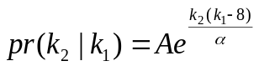

where A is a normalising constant and α determines the extent to which probability leaks to high k₂. When k₁ = 8 the prior is uniform in k₂ as required; when k₁ = 0 there is an exponential decay to higher k₂ controlled by α.

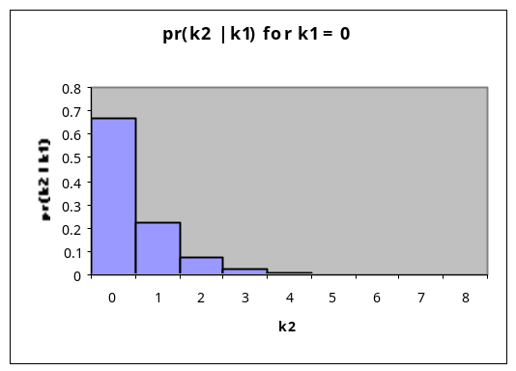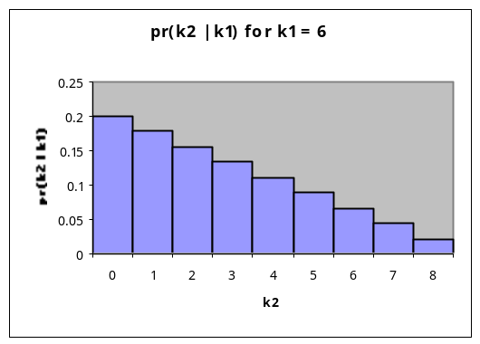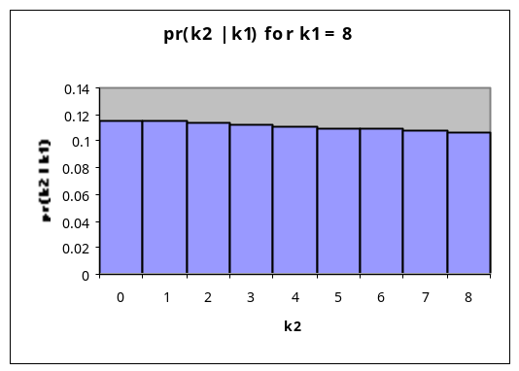

Figure 7.1 – Prior Distribution for k_{i}

We now face the typically Bayesian dilemma of how to set α, called the ‘regularisation constant’. Small α represents a strong belief that students weak in one section will know nothing in the harder sections, therefore favouring k-combinations such as (6,0,0) over (5,1,0). Large α says that students’ knowledge is less hierarchical. It would be possible to put a prior on α and then integrate over all values in some reasonable range, raising the question of what is ‘reasonable’. On the other hand, different analysts may legitimately choose different α reflecting their views on students’ knowledge. A discussion of the merits and technical details of both approaches can be found in [9] and [10]. We will take a pragmatic, empirical approach for the following reasons.

It is possible to have different regularisation for k₃ and k₂. One argument for this could be that, since there are more middling students than there are exceptional students, we should have a higher decay rate in k₃. This would be further justified if we could say that section three questions were much more difficult than section two, i.e. that the increase in difficulty was non-linear. Another argument says that many students will guess better in section two than in section three by narrowing down choices based on partial knowledge i.e. the distractors are easier to identify in section two. This would require a similarly sharp cut-off into section two. Experience suggests that the data will be good enough to decide this, and we propose to choose values for the two α that maximise the evidence for the model.

8. Whole-class Section Score Model (I₂)

We must now build a model in which both the correlations between students and between sections are considered. In the notation used previously we have:

where plain text letters now denote vector quantities such as m ≡ m_{j} = (m₁,m₂,…, m_{J}) and bold denotes matrix quantities such as S ≡ s_{ij} = (s₁₁, s₂₁, …, s_{N1}, s₂₁, s₂₂, …, s_{NJ}) for N students answering L questions in each of J sections on the paper with R responses from which to choose. We thereby recover a posterior distribution for m,α which we can maximise with respect to α as described, and use to assess the level of ability of the class. In our example above, J=3 sections, L=8 questions and R=4 choices.

Prior information comes in the form of correlations between students’ scores and between section scores for each student individually. The former correlation is encoded as before using the exponential decay prior for each k_{ij} around that section’s m_{j}, with fall off rate f_{j}. This prior is applied to each section independently allowing different f’s for each. This models the students’ tendency to score similarly due to the common setting and teacher. The latter correlation is encoded as above, although it is applied to the m_{j} rather than to the individual student’s set of k’s. This way we link the group’s scores in each section according to their increasing difficulty, expecting m_{j} < m_{j-1}.

Using our previous formula and inserting the additional correlations we can now write:

Substituting our form for pr(m₂|m₁) and using a scale parameter prior for α in a suitable range, as we did for f, yields Equation 8.1:

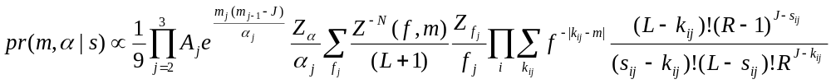

A computer programme ‘boqrat†’ was built to implement this formula and run for the example case J=3 sections, L=8 questions, R=4 choices.

9. Model Implementation Analysis

The programme was run against simple test data to check expected outcomes (see Table 9.1). These tests agree with a ‘common sense’ analysis of the scores.

Test | Student Scores (N=20) | Max. of pr(m)  (m₁,m₂,m₃) = Σm | % of posterior density
Test 1 | (8,8,s)  4 < s < 6 | (8,8,4) = 20 | 99.98%
Test 2 | (8,4,2) | (8,3,0) = 11  (8,3,1) = 12 | 58%  41%
Test 3 | (4,4,2) | (3,3,0) = 6  (3,3,1) = 7 | 58%  41%
Test 4 | (4,2,s)  0 < s < 8 | (3,0,0) = 3  (3,1,0) & (3,0,1) = 4  (3,1,1) & (3,0,2) = 5 | 51%  35%  11%

Table 9.1: Results of Simple Tests of ‘boqrat’ Computer Programme

The ‘toy’ datasets used earlier were adapted to provide section scores in keeping with the group’s expected grade. ToyA consisted in 20 students scoring 21, adapted so that each scored 8,7,6. ToyG consisted in 20 students scoring between 6 and 9; combinations used suggested extensive guess-work e.g. 2,0,6. ToyC consisted in 20 students scoring between 9 and 14; mostly sensible combinations such as 7,3,2 were used. The results, shown in Figure 9.1, can be compared with Figure 4.1 from the earlier model. We have a sharper posterior distribution for ToyA where all students scored the same, but a flattened and right-skewed result for both ToyC and ToyG. . The additional information provided by the section scores has lent some credibility to a higher level of group knowledge (and reduced guessing) because students generally scored higher in earlier sections.

The results are however somewhat sensitive to changes in α and, in particular when α is very small, the posterior can change by several percent. We chose to select α based on the evidence, but it turns out that reducing α always increases the evidence. To see why this is, consider for simplicity both α’s to be equal. They then come out from under the sum in Eqn. 8.1 as a constant multiplier. Making α smaller by a large factor then increases the value of each cell of the posterior by that factor, but should be offset by a worse fit to the data (smaller likelihood value). However, the model has another escape route available – the value of f can increase to broaden pr(k) and continue to fit the data. This was checked by obtaining the joint posterior pr(m, α, f | s) and noting the maximum in f for different α. In each case, as α decreased, the best f increased accordingly to fit the data; consequently the value in each posterior cell increased and therefore so did the evidence. This tells us that our model is over-complicated with more parameters than are needed to explain the data.

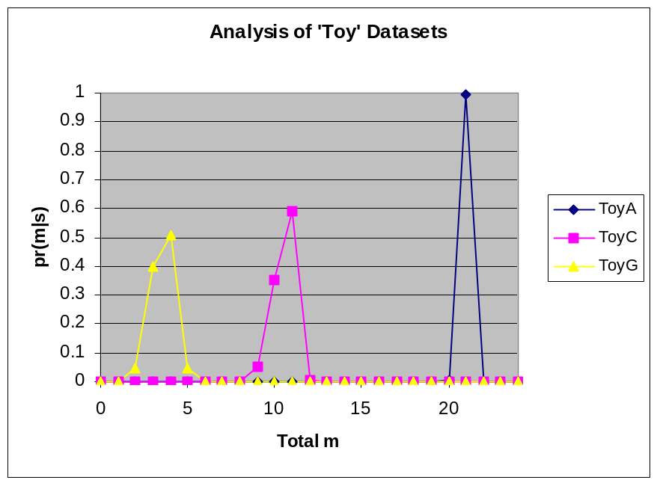

Figure 9.1 – Posterior for m for ‘Toy’ Scores Under New Model

An alternative and slightly less strict prior (which comes from the empirical form for the charge density in an atomic nucleus) was tried, with the algebraic form:
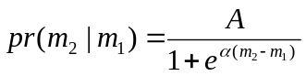

This time the density is broadly constant with increasing m₂ until m₂ = m₁ when an edge is reached and the probability rolls-off to zero (Figure 9.2). The precise shape of this roll-off is controlled by α. By setting α = 1 / (m₁ + a) we get a roll-off that is faster when m₁ is small, as required. This also removes the nuisance scale parameter, α, in favour of a location parameter a. Unfortunately this prior either gives lower evidence than the original prior (with smooth roll-off), or gives results that permit unsatisfactory m-combinations such as (6,6,6) (with higher-value , sharper cut-offs).

To remove the parameter altogether, a simpler functional form was tried. This uses a linear, rather than exponential, decay rate with a gradient dependent on the previous section score. A gradient of (m_{i-1} – 8)/32 was used, where m_{i-1} is the previous section’s m-value. This gives a flat prior for m_{i} when m_{i-1}=8 and a reducing, hard cut-off value for reducing m_{i-1}. Although this is initially disturbing as it fully forbids some m-values in some cases (i.e. sets some pr(m)=0), in practice the results showed little difference from those of the exponential prior with reasonable α. In projection, the results were indistinguishable to within 1%. This prior was then used as the basis for all further analysis.

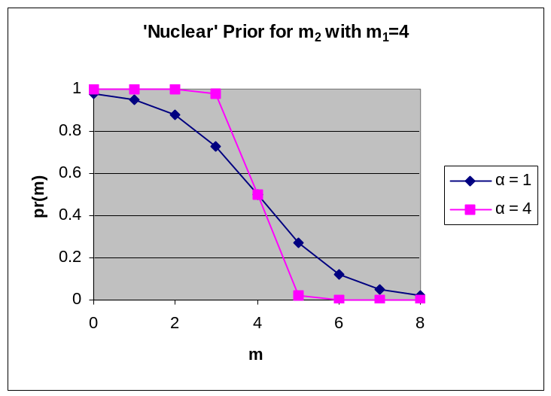

Figure 9.2 – ‘Nuclear’ Prior Distribution for m_{i}

10. Final Results

Figure 10.1 shows the results of applying the final model to the real class data analysed earlier.

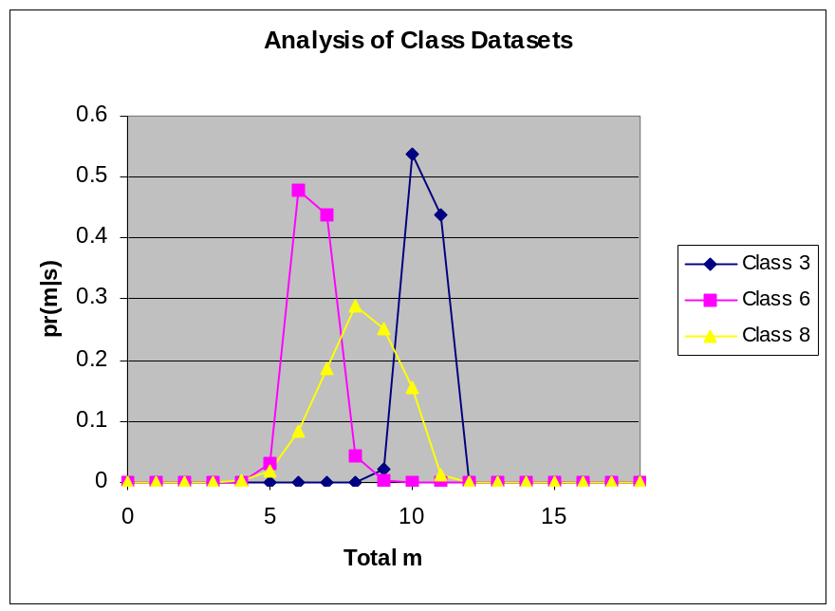

Figure 10.1 – Posterior for m for Real Class Scores Under New Model

Comparing Figures 5.1 and 10.1 we see that the posterior distributions for all classes have been skewed to the right. We conclude that the individual section scores show more evidence of knowledge than the first model predicted; they could show this for example by containing more scores like 8,4,0 than 4,8,0. Class 6 has the weakest skew – a look at the scores shows several guesswork combinations such as 5,3,5 and 2,1,3. Class 8 is interesting in that the data include students with scores of 8,6,6 and 8,5,5 as well as others with 5,0,1 and 6,0,2. Teachers would probably recognise a genuinely wide range of knowledge in this group and this is reflected in the flatter posterior for this group.

The results from using the linear prior on m consistently produce significant increases in evidence over the exponential models in many cases. In some cases the evidence is smaller but only by factors of O(1). This check confirms that the choice of prior is satisfactory.

Comparing the new model (I₂) to the original model (I₁, with only total score, not section scores) is not simple because we have essentially different data. This means that our evidence procedure is not valid. However, a little manipulation shows that:

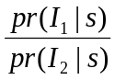 = 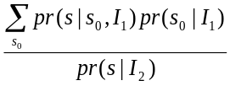

where s represents the new, section data and s₀ represents the original data. In the sum, any dataset s₀ in which the section scores do not add to the total score has first term zero. Only the original dataset meets this criterion. We therefore retain the evidence ratio, but we modify the original model by a weight factor equivalent to the probability of getting the section scores given the full scores. Model I₁ does not know about sections, so all valid section scores are equally probable. If there are W ways of making up a given total score from section scores, then the weight factor on that score is W / (L+1)³ (L being 8 in the present case).

Table 10.1 shows the evidence values for various data and model combinations. As discussed earlier, model I₁ is overwhelmingly supported over the uncorrelated model, I₀ (see rows B/A). Similarly model I₂ is supported over its uncorrelated model (say I₀’, as shown in row F/E).

For classes 3 and 8, I₂ is supported over I₁ (row F/D) but I₁ expects the data better for class 6. The reason for this is that, as mentioned before, class 6’s section scores suggest a significant amount of lucky guessing. We can see this in row E/A in Table 10.1 which gives the relative probability of the section data and the total score data under an assumption of no correlation of any kind; class 6’s section data are highly implausible. As noted there is little skew in results from I₁ to I₂ as I₁ has estimated the amount of guessing about right for this group. Having chanced on a good fit to the section data, I₁, the simpler model, is preferred – a statement of Occam’s Razor.

 |  | Dataset
 | pr(s) given … | Class 3 | Class 6 | Class 8
A | Uncorrelated Total Scores | 1.59E-36 | 5.73E-28 | 4.45E-24
B | Model (I₁) (Total Scores) | 9.43E-29 | 7.08E-20 | 2.43E-21
C | ‘Number of Ways’ Factor | 1.68E-32 | 2.89E-24 | 6.29E-22
D | Model I₁ x Factor | 2.47E-60 | 1.06E-44 | 9.56E-44
E | Uncorrelated Section Scores | 4.49E-54 | 8.75E-81 | 1.46E-62
F | Model (I₂) (Section Scores) | 8.73E-43 | 1.65E-56 | 1.08E-43
B/A | I₁ vs. I₀ | 5.93E+07 | 1.24E+08 | 5.46E+02
F/E | I₂ vs. I₀' | 1.94E+11 | 1.89E+24 | 7.40E+18
F/D | I₂ vs. I₁ | 3.53E+17 | 1.56E-12 | 1.13E+00
E/A | Score Consistency | 2.82E-18 | 1.53E-53 | 3.28E-39

Table 10.1: Comparison of Evidence for Models

Table 10.2 shows a comparison between a traditional analysis of the raw scores and the results found above. The traditional approach of looking at means of total scores only would congratulate the students or teacher of class 8 and vilify that of class 6 and class 3 (being only a little ahead of class 8). Even an enlightened school working on “normal” statistics of the raw scores will not be able to draw valid, clear conclusions as the error bars are too large as a result of guessed answers. There is only weak evidence in the traditional analysis for any difference between the groups. The Bayesian analysis has plenty to say: class 3’s level of knowledge matches what would be expected of C-grade students; class 8 has done well, although there is a wider range of knowledge within the group; class 6 has under-performed. In addition, the full posterior can be used to ask more detailed questions such as “what is the probability that class 8 only knew answers in section one?” (0.18), or “what is the probability that class 6 knew fewer that two questions over sections two and three?” (0.55). These can be used to inform teaching practice.

 | Moments of pr(m|s) |  | Statistics of ∑s
Dataset | E(m) | √V(m) | μ | σ
Class 3 | 10.41 | 0.29 | 13.25 | 1.96
Class 6 | 6.51 | 0.45 | 10.86 | 2.00
Class 8 | 8.18 | 1.71 | 12.00 | 2.56

Table 10.2: Numerical Comparison of Scores with Posterior

Conclusion

Current analysis of GCSE modular science scores is often unscientific. The use of UMS scores under-represents the contribution of high-achievers. The use of simple averages (even with consideration of variance) does not give a true picture of a group’s performance because no allowance is made for guess-work. The Bayesian method offers a probability distribution for true performance providing the opportunity to ask more complex questions of the data. This information can be used both to inform individuals’ teaching, and to assist Heads of Science in identifying effective teaching methods for different groups. With the expected continuation of this form of assessment in the new 2006 science specifications, this technique could be a useful tool for use in schools in the future.

References

[1] Angoff, W.H. and Schrader, W.B. (1981). “A study of alternative methods for equating rights scores to formula scores”. Research Report from the Educational Testing Service.

[2] Muijtjens, A.M.M., van Mameren, H., Hoogenboom, R.J.I., Evers, J.L.H. and ven der Vleuten, C.P.M. (1999). “The effect of a 'don't know' option on test scores: number-right and formula scoring compared”. Medical Education, 33, pp. 267-275.

[3] Bush, M. (1999). “Alternative Marking Schemes for Online Multiple Choice Tests”. In proceedings of Seventh Annual Conference on the Teaching of Computing.

[4] Bloom, B. S. (ed.) (1956). “Taxonomy of Educational Objectives, Handbook 1: Cognitive Domain” , Addison-Wesley.

[5] Simkin, M. G., Kuechler, W. L. (2005). “Multiple-Choice Tests and Student Understanding: What Is the Connection?” In Decision Sciences – The Journal of Innovative Education, January 2005, vol. 3, no. 1, pp. 73-98(26), Blackwell

[6] Kurhila et. al. (2001). “Bayesian Modelling in an Adaptive Online Questionnaire for Education and Educational Research”. In proceedings of PEG2001.

[7] Box, G. E. P., Tiao, G. C. (1992). “Bayesian Inference in Statistical Analysis”, Wiley Classics Library, London.

[8] Bloom, B. S. (ed.) (1956). “Taxonomy of Educational Objectives, Handbook 1: Cognitive Domain” , Addison-Wesley.

[9] MacKay, D. J. C. (1999). “Comparison of Approximate Methods for Handling Hyperparameters”, J. Neural Comp., 11, pp1035-1068.

[10] Bretthorst, G. L. (1988). “Bayesian Spectrum Analysis and Parameter Estimation”, Springer-Verlag.

Full mathematical details are intended for readers familiar with Bayesian methods.
† Inevitably this is an acronym – it stands for ‘Bayesian objective questioning results analysis tool’. The Windows executable can be downloaded from the author’s web site.
A different analyst may disagree that this score is unsatisfactory and choose to use this form of prior.

